|  |  |
| --- | --- |
| Course Number | ELE532 |
| Course Title | Signals and Systems I |
| Semester/Year | F2022 |
| Instructor | Dimitri Androutsos |
| TA Name | Sarina Taki |
| Section No. | 08 |
| Submission Date | 30-October-2022 |
| Due Date | 31-October-2022 |

|  |  |  |
| --- | --- | --- |
| Student Name | Student ID | Signature* |
| Ahmad El-Gohary | 501011852 |  |

*By signing above, you attest that you have contributed to this submission and confirm that all work you have contributed to this submission is your own work. Any suspicion of copying or plagiarism in this work will result in an investigation of Academic Misconduct and may result in a “0” on the work, an “F” in the course, or possibly more severe penalties, as well as a Disciplinary Notice on your academic record under the Student Code of Academic Conduct, which can be found online at:

http://www.ryerson.ca/content/dam/senate/policies/pol60.pdf

Contents

Introduction 3

Lab Results 3

Conclusion 22

# Introduction

The objective of this lab is to learn how to use M-Files, create signals and perform convolution.

# Lab Results

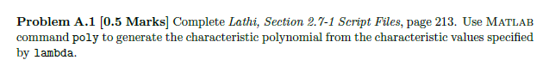



h1(t) = 0.2

h2(t) = -0.2

h3(t) = -1

h4(t) = -0.2 and -1



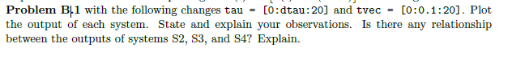

h4(t) is h2(t) - h3(t) using this we can derive the relation between the systems.

s2= h2(t-τ) x(τ)

s3= h3(t-τ) x(τ)

Subtract s2 from s3 and we get h2(t-τ) x(τ) – h3(t-τ) x(τ) = [h2(t-τ) – h3(t-τ)] x(τ) = h4(t-τ) x(τ) which is s4 and this proves the graphs

# Conclusion



The duration of the convolution is equal to the sum of both convoluted functions